Week 5 – 1:

--Nested Loops – while sand for , Jumps Loops

ROLL NO.:241501059

Name: Gowtham M

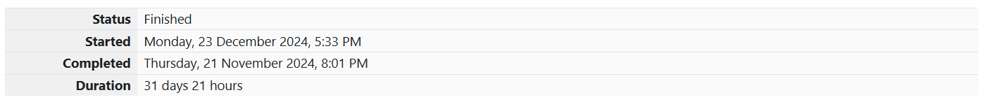

Q1) Write a program that prints a simple chessboard.

**Input format:**

The first line contains the number of inputs T.

The lines after that contain a different value for size of the chessboard

**Output format:**

Print a chessboard of dimensions size * size.

Print W for white spaces and B for black spaces.

**Sample Input:**

2

3

5

**Sample Output:**

WBW

BWB

WBW

WBWBW

BWBWB

WBWBW

BWBWB

WBWBW

**Code:**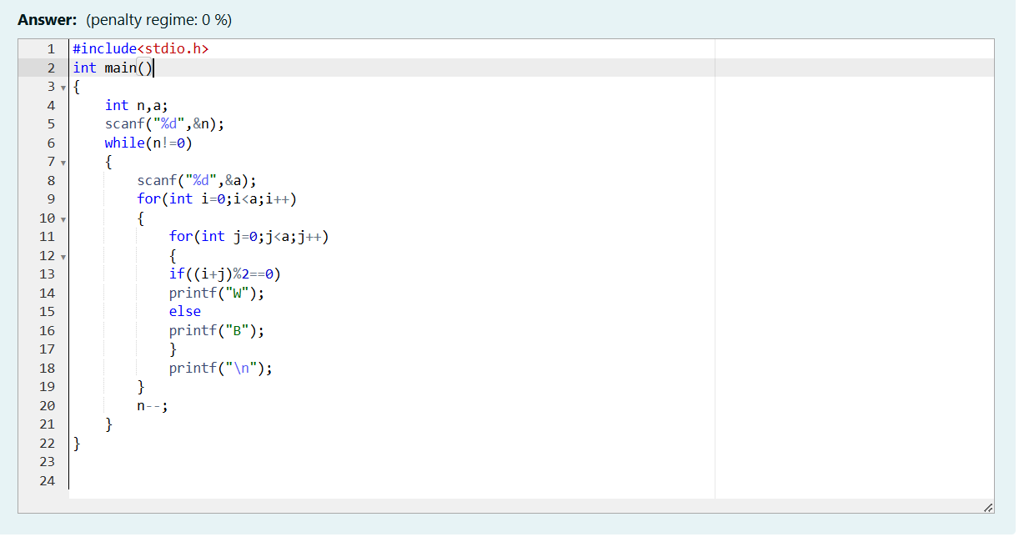

OUTPUT:

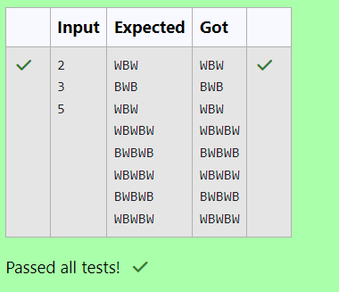

**Q2)** Let’s print a chessboard!

Write a program that takes input:

The first line contains T, the number of test cases

Each test case contains an integer N and also the starting character of the chessboard

**Output Format**

Print the chessboard as per the given examples

**Sample Input:**

2

2 W

3 B

**Sample Output:**

WB

BW

BWB

WBW

BWB

**code**

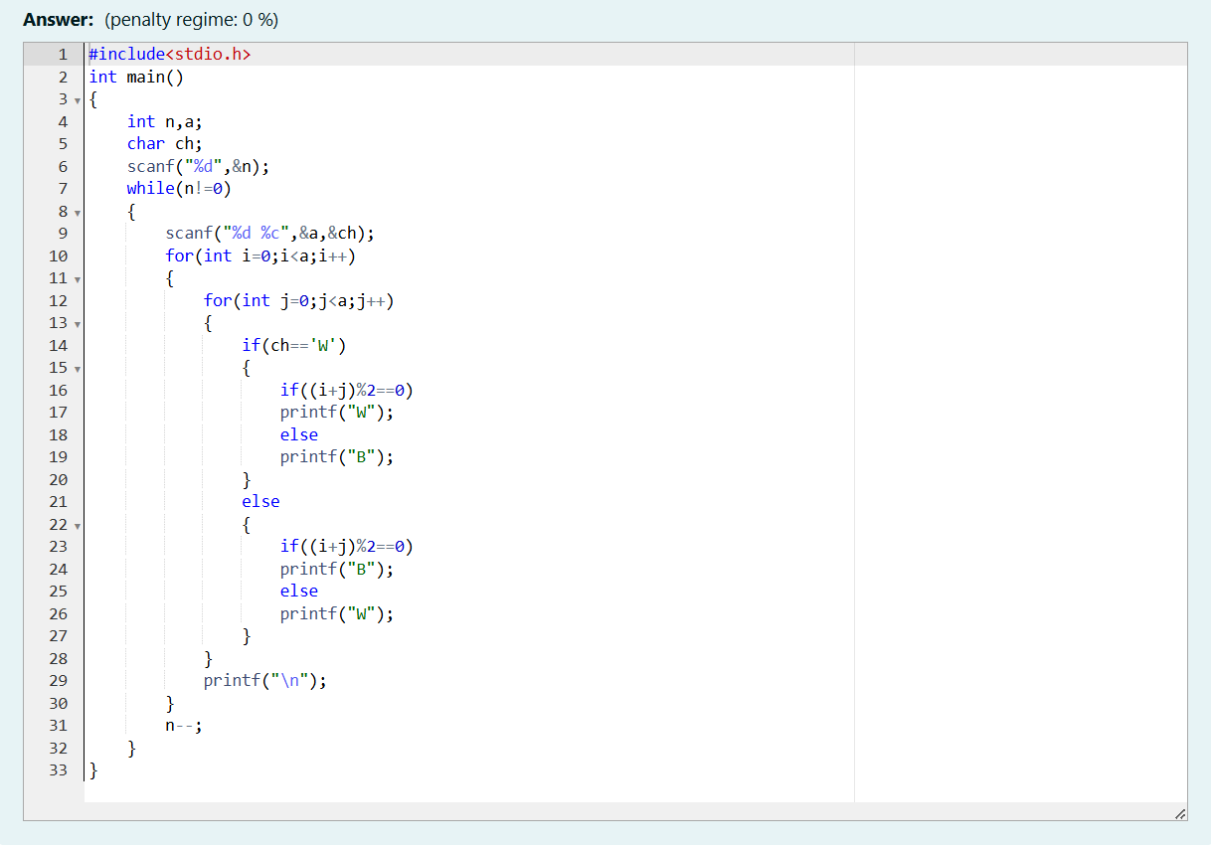

OUTPUT:

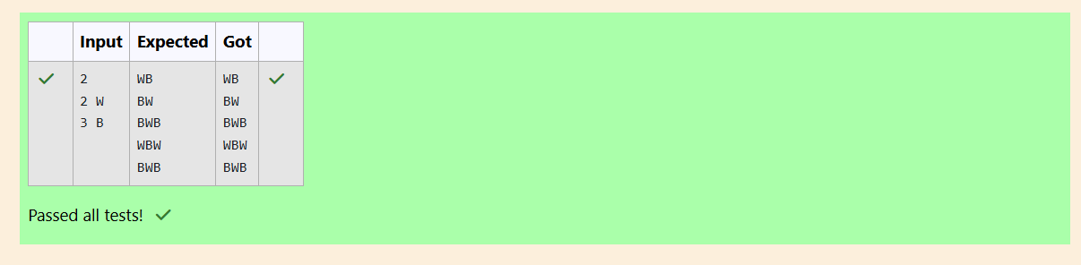

**Q3)** Decode the logic and print the Pattern that corresponds to given input.

If N= 3 then pattern will be:

10203010011012

**4050809

****607

If N= 4, then pattern will be:

1020304017018019020

**50607014015016

****809012013

******10011

Constraints: 2 <= N <= 100

**Input Format**

First line contains T, the number of test cases, each test case contains a single integer N

Output Format

First line print Case #i where i is the test case number, In the subsequent line, print the

pattern

**Sample Input**

3

3

4

5

**Sample Output**

Case #1

10203010011012

**4050809

****607

Case #2

1020304017018019020

**50607014015016

****809012013

******10011

Case #3

102030405026027028029030

**6070809022023024025

****10011012019020021

******13014017018

********15016

**Code:**

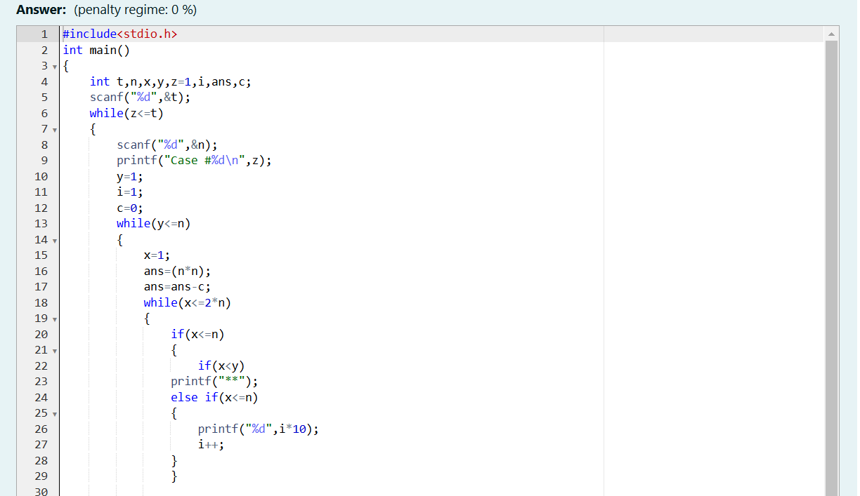

OUTPUT: